Flow Chart

Main flow
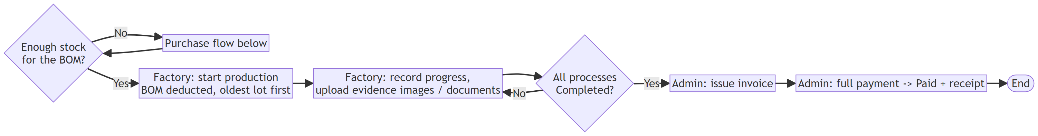

Purchase flow
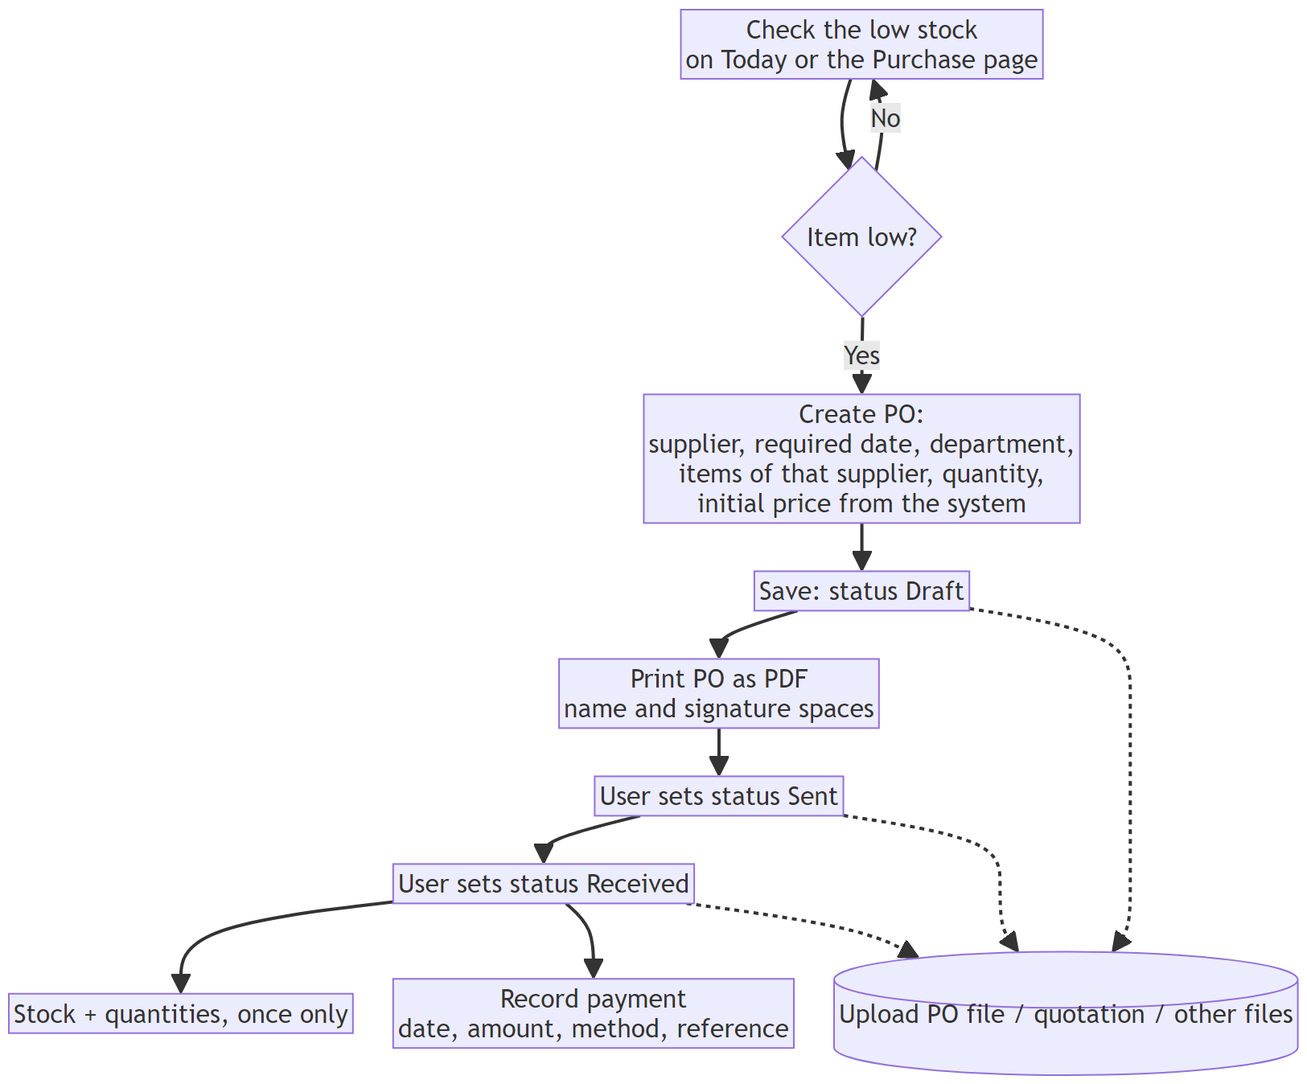

PO status
Lines can be edited only in Draft. A Draft PO can be deleted.

QT status

Order status
The status of an order is computed from its processes, not set by hand. Draft also covers an order that was started but has no progress yet (the page says "Production started").

Process status

Invoice status

Stock changes
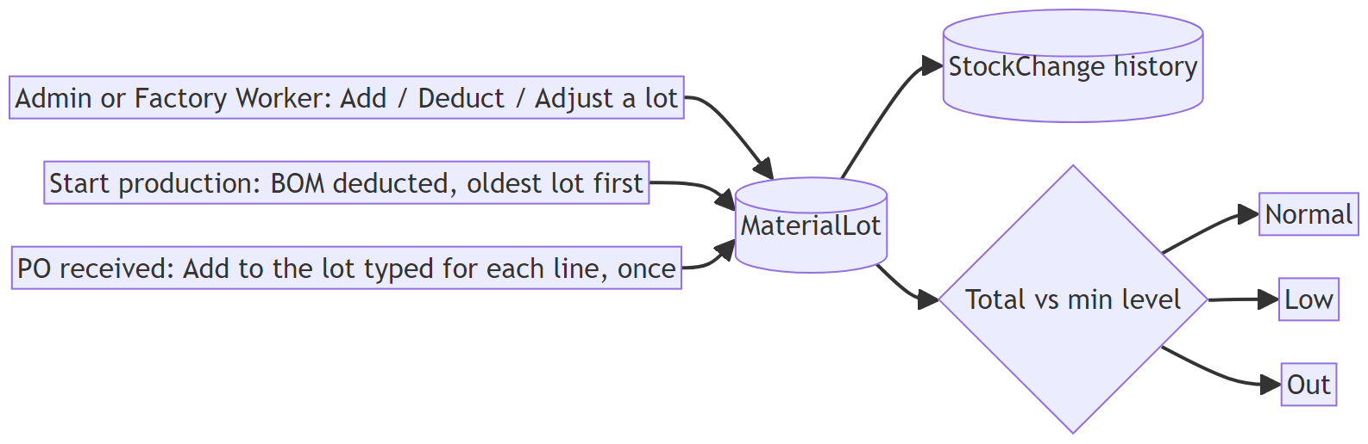

Confirm QT: checks
